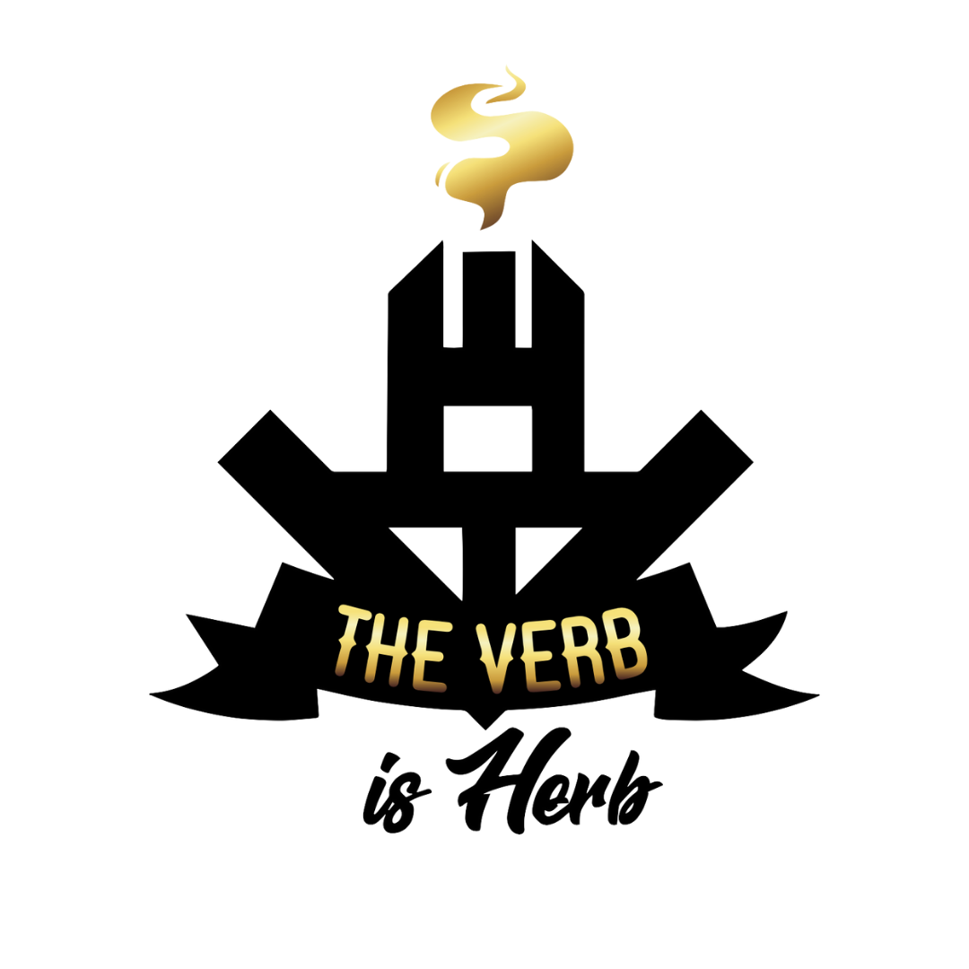

CONSUMER EDUCATION
Massachusetts General Laws

Adult Use Marijuana Program In November 2016, Massachusetts voters passed Question 4, resulting in the adoption of Chapter 334 of the Acts of 2016, making the possession and personal cultivation of marijuana legal for all adults 21 years of age and older and creating a regulatory system to license for-profit, adult-use, marijuana businesses. The Massachusetts legislature immediately set out to revise that law, and on July 28, 2017, Governor Baker signed Chapter 55 of the Acts of 2017, amending the adult-use law passed by the voters. Under the framework of the revised law, adult-use marijuana businesses are licensed by a five-member administrative body known as the Cannabis Control Commission (the “Commission”), which promulgated the regulations, guidelines, and protocols necessary for the issuance of adult-use marijuana business licenses on March 23, 2018. Adult-use marijuana sales are taxed at 20% (10.75% excise tax, 6.25% sales tax, and a 3% local option excise tax).

For additional information on the Adult-Use of Marijuana Program, visit the Commission’s website: https://mass-cannabis-control.com/

Please Use Responsibly

The Law

- It is illegal to drive or operate heavy machinery while under the influence of marijuana (M.G.L. c. 90, § 24).
- Consumers should speak with a healthcare provider before using marijuana, especially if they are using medications.
- Consumers have reported a variety of side effects associated with the use of marijuana including dry mouth, dizziness, paranoia, anxiety, slowed reaction times, and impaired motor skills. Side effects can vary for different consumers.
- Marijuana consumption is not permitted in public, and furthermore, consumption is not permitted in or around Rebelle’s facilities.
- Consumers may possess up to one ounce of marijuana flower, 500mg of THC in edibles, or five grams of marijuana concentrate. That carry limit is also the purchase per day limit per customer.
- Individuals can only share or gift up to 1 ounce of marijuana flower (or its equivalent) with adults ages 21 and over, without any form of compensation.
- Like alcohol, consumers may not have an open container of adult-use marijuana/marijuana products in the passenger area of their car.
- An “open container” includes a package with its seal broken or a package from which the contents have been partially removed. The “passenger area” does not include a trunk or a locked glove compartment.
- Stay in Massachusetts: Do not cross state lines with marijuana.
- Consumers may not sell Marijuana to any other individual. Selling marijuana to others is illegal. First time offense (under 50 lbs) may be punishable by up to 2 years imprisonment / $5,000 fine. Subsequent offenses may be punishable by up to 2.5 years imprisonment / $10,000 fine.
- No Marijuana Product, including Marijuana, may be sold or otherwise marketed for adult use that has not first been tested by Independent Testing Laboratories, except as allowed under 935 CMR 500.000. The product must be deemed to comply with the standards required under 935 CMR 500.16
- Marijuana consumption is not permitted in public, and furthermore, consumption is not permitted in or around The Verb is Herb facilities
Note that this is not an exhaustive list of all penalties associated with any illegal possession, distribution, or production of marijuana

Children and Pets
- Never expose cannabis to children or pets. Always store cannabis products in a locked area that is out of sight and access of children and pets. Keep cannabis in its original child-resistant packaging. Secondhand cannabis smoke contains THC and other chemicals that can negatively affect the health of children and pets. If you think a child may have ingested cannabis, call the local Poison Control Center at 800-222-1222. If a child needs immediate medical help, call 911.

Pregnancy
- If you are pregnant or breastfeeding, or plan to become pregnant soon, leading doctors’ organizations recommend that you do not use marijuana. Smoking marijuana or consuming edible cannabis products can expose your baby to potentially harmful substances.

Know Your Product

Marijuana Strains & Cannabinoids

Marijuana comes in hundreds of different strains that are constantly changing but are typically classified into four groups: Sativa, Indica, Hybrid, and Cannabidiol (“CBD”). Each group is made up of a variety of strains, all with different cannabinoid profiles, terpenes, and flavonoids.

Sativa: Sativas are reported to increase energy and focus, generally recommended for daytime use.

Indica: Indicas are reported to promote relaxation and promote sleep for evening use.

Hybrid: Hybrid strains are produced when cultivators cross-breed different indica and sativa strains to increase the desired traits and breed out the undesired to meet specific needs.

Cannabinoids

Cannabinoids are chemical compounds found in the cannabis plant which bind and react with the human endocannabinoid system to produce therapeutic effects. The most commonly known cannabinoids are Tetrahydrocannabinol (THC) and Cannabidiol (CBD). More than 100 other compounds are found in the plant. Though the number of peer-reviewed scientific papers on cannabinoids is very limited, research on the ability of cannabinoids to treat disease is remarkable. Scientists around the world are devoting their research time to learning more about cannabinoids and their vast therapeutic applications.

The first cannabinoid to be identified was Tetrahydrocannabinol (“THC”), which is known to produce psychoactive effects or the feeling of being “high.” Apart from its recreational use, it can be used to relieve pain, reduce vomiting and nausea, reduce inflammation, aid sleep, reduce muscle spasms, relieve anxiety, and stimulate the consumer’s appetite.

Cannabidiol (“CBD”) is another cannabinoid with varying benefits that produces very little to no psychoactive effects or “high.” Reported therapeutic uses include pain relief, killing or slowing bacterial growth, reducing blood sugar levels, reducing seizures, relieving anxiety, and inhibiting tumor and cancer growth.

Other cannabinoids such as Cannabichromene (“CBC”), Cannabigerol (“CBG”), Cannabinol (“CBN”), Tetrahydrocannabinolic Acid (“THCA”), and Tetrahydrocannabivarin (“THCV”) are reported to have varying benefits as well. Some of these benefits include suppression of appetite, aiding sleep, reducing risk of artery

Terpenes

Terpenes are another important compound found in the cannabis plant. They are responsible for its unique aroma. The wide variety of terpenes give different varieties of cannabis a wide range of scents. In recent years, scientists have found that terpenes do much more than produce an aroma. These compounds may boost and expand the therapeutic effects of cannabinoids, especially THC. Terpenes can be extracted from the cannabis plant and infused into distilled and extracted THC and CBD.

blockage, nervous system protectants, suppressing muscle spasms, modulating the immune system, and relieving pain.

Products Offered
The Verb is herb offers a broad range of products and is constantly updating its selection. The Verb is herbs daily menu is available online at: www.theverbisherb.com Below is a description of the various marijuana products that will be offered at The verb is herb.
Marijuana Flower for Smoking and Vaporizing
The verb is herb will offer a wide variety of marijuana strains and products for consumers. Strains will be consistently available and reviewed on an ongoing basis based on feedback from consumers and overall demand.
Marijuana Infused Products (MIPs)
Edible products will be offered, such as chocolates and lozenges. Pills will be available and made from an infused coconut oil. MIPs provide an alternative method for consuming marijuana. MIPs are an attractive alternative for consumers who are unwilling to smoke as they do not irritate the throat. In many cases, MIPs offer a longer lasting effect.
Tinctures
Tinctures are liquids that have been infused with marijuana. Tincture can be administered to the consumer using an eyedropper to place the liquid under the tongue. Tinctures are easy to administer, discreet, and are not intimidating for elderly consumers or consumers who have difficulty swallowing. Doses are easily measured and tend to be more consistent than edibles. Tinctures do not negatively impact the lungs.
Topicals
Ointments, sprays, lotions, transdermal patches and balms that are beneficial for treating acute pain in different regions of the body. Topicals have a delayed onset effect but can last for up to eight (8) hours for some consumers. Topical treatments do not have any known negative effects on the lungs or throat. Lotions appeal to elderly consumers who are used to using lotions to treat arthritis or acute pain. Topical marijuana treatments generally have no psychoactive effect or “high,” but rather only a therapeutic effect on the consumer’s specific condition.
Concentrates
Varieties: Hash, oils, and waxes designed for consumers who prefer to smoke or vaporize small amounts of highly concentrated marijuana to receive the complete effect. Concentrates allow for a fast onset without the need to smoke excessive amounts of marijuana.
Paraphernalia
Classic vaporizers, portable vaporizers, vaporizer pens, volcano vaporizers, digital vaporizers, water pipes, smoking pipes, and rolling papers.
Related Supplies
Grinders, scales, rolling machines, rolling trays, rolling boxes, rolling mats, filters, flavoring for flowers, cleaning accessories, lighters, vaporizer replacement parts, air fresheners, air purifiers, storage jars, lock boxes and other secure or inconspicuous containers for storage of marijuana.
These supplies will assist consumers with the storage, consumption, rationing, titration, and dosing of the various forms of marijuana. Marijuana containers and storage supplies will ensure that the consumer’s marijuana is stored safely and securely.

Methods of Administration & Dosing
There are three primary ways to consume marijuana and each has its own unique use case and benefits. Different products will vary in potency, cannabinoid profile, and effects. Consumers should experiment to find the ideal dose for their desired effects and are encouraged to keep a log of consumption methods, strain information, and effects. A consumer’s tolerance will vary based on a variety of factors including weight, body chemistry, and metabolism. Low and slow is how all new cannabis users should approach dosing. All marijuana products will be lab tested and clearly labeled to ensure consistent dosing and packaging.

Inhalation

Inhalation is the most popular consumption method with the quickest effect. As the user inhales, the cannabinoids are introduced into the bloodstream, having an almost instant effect. The effects can last anywhere from ninety (90) minutes to several hours, and peak effects are usually felt after thirty (30) minutes. It is good practice to wait at least 45 min before increasing dosage.

Combustion

Combustion is the most common way marijuana is inhaled. Effects can be felt within minutes, and depending on the consumer, strain, cannabinoid content, etc., the effects typically wear off fully within 90 minutes to 4 hours
Start with 1 single inhale lasting 3 seconds and wait 45 minutes before repeating.

Vaporizing

Vaporizing is an alternative way of inhaling marijuana that involves heating the marijuana flower or concentrates to a temperature that produces vapor without combustion.

Start with 1 single inhale lasting 3 seconds and wait 20 minutes before repeating. Vaporizer cartridges should be stored upright and not lying down.

Marijuana Vaporizer Devices have been tested for Vitamin E Acetate and other contaminants, with no adverse findings.

WARNING: Vaporizer Devices may contain ingredients harmful to health when inhaled.

Consumers shall have access to the test results of Marijuana Vaporizer Devices including copies of any Certificates of Analysis provided by the device’s manufacturer.

Oral

Oral consumption of marijuana is a popular administration method for consumers who prefer not to inhale anything and are looking for longer lasting effects. Within oral consumption there are two VERY different categories.

Edibles

Marijuana Infused Products (MIPs) are food products such as chocolates, lozenges, pastries, or capsules that can be swallowed and processed by the liver creating a new more potent cannabinoid. This process takes much longer (2-3 hours) and produces a much stronger effect. Low and slow and it is recommended to not increase the dose until at least 2-3 hours have passed.

- START SLOW: start with 1 serving of 1-5mg until you know how it will affect you.
- WAIT: consumables can take up to 2 hours or longer to take full effect. Wait before increasing your dose.
- DO NOT MIX: do not mix consumables with alcohol or other controlled substances! 4. SAFETY: Keep away from children and pets. Store your medicine in its original childproof packaging.

Sublingual marijuana products are designed to be taken orally but held under the tongue for a few minutes allowing the cannabinoids to enter through the blood brain barrier. These effects are felt within 15-30 min and have a similar effect to smoking because it did not pass through your liver. This is a great option for first timers giving you the ability to microdose easily.

- START SLOW: Start with 1 serving of 1-5mg until you know how it will affect you.
- WAIT: Tinctures can take 20-30 minutes or longer to take full effect. Wait before increasing your dose.

Topical

Topical marijuana products are absorbed through the skin to target specific areas. Often, topicals do not produce psychoactive effects or a “high” for consumers and is one of the safest consumption methods.

All topicals can take a few minutes to take effect with 1-2 hours of duration. If the topical includes THC, avoid areas of the groin or underarms. Wash hands after every use. Could have a psychotropic effect.

Marijuana Vaporizer Devices

Marijuana Vaporizer Devices have been tested for Vitamin E Acetate and other contaminants, with no adverse findings.

WARNING: Vaporizer Devices may contain ingredients harmful to health when inhaled.

Consumers shall have access to the test results of Marijuana Vaporizer Devices including copies of any Certificates of Analysis provided by the device’s manuf

Documenting your Experience:
Since every person is different, It can be tricky to figure out the exact dose and timing of your cannabis. The Verb is Herb recommends documenting your experience, to find out what works best for you!

STRAIN AND PRODUCT TRACKING JOURNAL
Date: __________________________________ Time: ________________________________
Product: ________________________________ Dosage _______________________________
Please Circle
Type: Indica | Sativa | Hybrid | High- CBD
Method of use:
Smoke | Vaporizer | Edible | Tincture | Topical
Notes:_______________________________________________________________________________________________________________________
Date: __________________________________ Time: ________________________________
Product: ________________________________ Dosage _______________________________
Please Circle
Type: Indica | Sativa | Hybrid | High- CBD
Method of use:
Smoke | Vaporizer | Edible | Tincture | Topical
Notes:_______________________________________________________________________________________________________________________
Date: __________________________________ Time: ________________________________
Product: ________________________________ Dosage _______________________________
Please Circle
Type: Indica | Sativa | Hybrid | High- CBD
Method of use:
Smoke | Vaporizer | Edible | Tincture | Topical
Notes:_______________________________________________________________________________________________________________________

START LOW, GO SLOW.

Dosage and Labeling

• Different products will vary in potency, cannabinoid profile, and effects. Consumers should experiment to find the ideal dose for their desired effects and are encouraged to keep a log of consumption, methods, and effects. A consumer’s tolerance will vary based on a variety of factors that include weight, body chemistry, and metabolism. All marijuana products will be lab tested and clearly labeled to ensure consistent dosing and packaging.

• When consuming MIPs, it is important for consumers to wait the appropriate amount of time before consuming more to reach a desired effect. Consumers should start with a low dose and should not increase it until they know the impact and the timing it takes to reach such an impact. A common mistake with MIPs consumption is taking too high of an initial dose. Such mistakes can be avoided if consumers “start low and go slow” and carefully monitor the effects.

• When consuming MIPs, it is recommended that consumers do so on a full stomach in order to decrease the intensity of the effects. It is also recommended that marijuana should not be used in conjunction with alcohol or other drugs, and consumers should not operate a vehicle or machinery while using marijuana. For women who are pregnant, there may be additional health risks associated with consumption of marijuana. All consumers should consult with their physicians about health and safety risks associated with using marijuana.

• The labels on marijuana products will outline the product’s cannabinoid profile and dosage information. Consumers should read the labels before purchasing and using marijuana to ensure they have the correct and desired products and doses. Consumers should consult an Emerald Grove agent if they have additional questions.

Method of Consumption & Dosages
Method of Consumption | Examples of Product Types | Onset of Effects / Duration
Inhalation | Flower & Vapes | 1 – 5 min / 1 – 4 hours
Concentrates | Wax, Sugar, Shatter, Etc | 1 – 5 min / 1 – 4 hours
Edibles | Gummies, Chocolates, Mints , Etc | 30 – 2 hours / 3 – 8 hours

TOLERANCE, DEPENDENCE AND DISCLAIMERS
Regardless of the type of medication, some patients may experience dependence or addiction to a substance. It is important to recognize the signs of addiction and abuse. When a patient becomes dependent on a substance and stops use, physical and mental symptoms will occur. Below are some symptoms and signs of dependency or substance abuse:
- Not meeting obligations and work responsibilities, or cutting back on social or recreational activities because of drug use.
- Continuing to use the drug, even though you know it’s causing problems in your life or causing you physical or psychological harm.
- Over time, needing more of the drug to get the same effect.
- Making certain that you maintain a supply of the drug.
- Doing things to get the drug that you normally wouldn’t do, such as stealing.
- Driving or doing other risky activities when you’re under the influence of the drug.
- Failing in your attempts to stop using the drug.
- Experiencing withdrawal symptoms when you attempt to stop taking the drug.
- Withdrawal The main behavioral symptoms of marijuana withdrawal include:
- • Being irritable
- • Feeling anxious or worried
- • Feeling depressed
- • Being restless
- The physical symptoms can include:
- • Stomach pain
- • Sweatiness
- • Shakiness • Fever
- • Chills • Headache
- • Having trouble sleeping at night and feeling tired during the day
- • Having low appetite or losing weight

If you are concerned that you are developing a dependency please contact your physician immediately. Although The Verb is Herb has no affiliation with the below programs, these may prove to be a good resource if you need help with dependency.
- Addiction Treatment Center of New England 77F Warren St, Bldg 5 Brighton, MA 02135(617) 254-1271 www.atcne.net
- MA Substance Use Helpline 800-327-5050 www.helpline.org
- Learn to Cope508-738-5148www.learn2cope.org
Marijuana has not been analyzed or approved by the FDA. There is limited information on the side effects of using marijuana and there may be associated health risks. Marijuana use during pregnancy and breastfeeding may pose potential harms. Marijuana should be kept away from children. When under the influence of marijuana, driving is prohibited by M.G.L.c. 90, Section 24. Do not drive or operate machinery when under the influence of marijuana. The claims in this Patient Guide have not been analyzed or evaluated by the FDA for safety or efficacy. Suggested effects and benefits of cannabis varieties and product types are based on anecdotal evidence.

